- Arithmetic Operations using Functions
#include <stdio.h>
float add(float a, float b)
{
return a + b;
}
float sub(float a, float b)
{
return a - b;
}
float mul(float a, float b)
{
return a * b;
}
float divi(float a, float b) {
return b != 0 ? a / b : 0;
}
int main() {
float x, y;
printf("Enter two numbers: ");
scanf("%f %f", &x, &y);
printf("Addition = %.2f\n", add(x, y));
printf("Subtraction = %.2f\n", sub(x, y));
printf("Multiplication = %.2f\n", mul(x, y));
printf("Division = %.2f\n", divi(x, y));
return 0;
}
}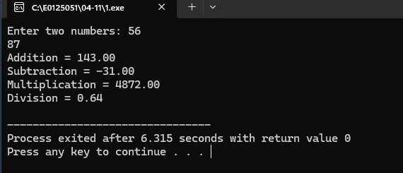
- Factorial of a Number using functions
#include <stdio.h>
int factorial(int n) {
int f= 1;
for (int i =1; i <=n; i++)
f *= i;
return f;
}
int main() {
int num;
printf("Enter a number: ");
scanf("%d", &num);
printf("Factorial of %d = %d\n", num, factorial(num));
return 0;
}
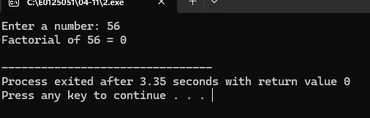
3. Fibonacci Series using Functions
#include <stdio.h>
void fibonacci(int n) {
int a = 0, b = 1, c;
printf("Fibonacci Series: %d %d ", a, b);
for (int i = 2; i <n; i++) {
}
c= a+b;
printf("%d ", c);
a = b;
b = c;
}
int main() {
int n;
printf("Enter number of terms: ");
scanf("%d", &n);
fibonacci(n);
return 0;
}
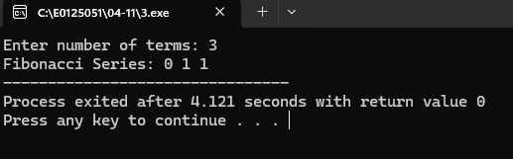
4.Factorial using Recursive Function

#include <stdio.h>
int factorial(int n) {
if (n==0)
return 1;
else
return n * factorial(n - 1);
}
int main() {
int num;
printf("Enter a number: ");
scanf("%d", &num);
printf("Factorial of %d = %d\n", num, factorial(num));
return 0;
}

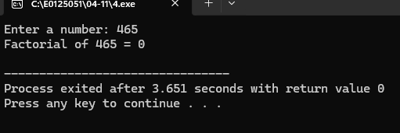

5. Fibonacci Series using Recursive Function
#include <stdio.h>
int fibonacci(int n) {
if (n ==0) return 0;
else if (n== 1) return 1;
else return fibonacci(n - 1) + fibonacci(n - 2);
}
int main(){
int n;
printf("Enter number of terms: ");
scanf("%d", &n);
printf("Fibonacci Series: ");
for (int i = 0; i <n; i++)
printf("%d ", fibonacci(i));
return 0;
}
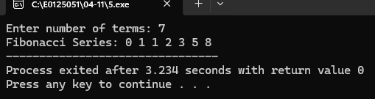

6. Swap Two Numbers using Call by Value and Call by Reference
#include <stdio.h>
void swapByValue(int x, int y) {
int temp = x;
x = y;
y = temp;
}
void swapByReference(int *x, int *y) {
int temp = *x;
*x = *y;
*y = temp;
}
int main() {
int x, y;
printf("Enter two numbers: ");
scanf("%d %d", &x, &y);
printf("Before Swap: x = %d, y = %d\n", x, y);
swapByValue(x, y);
printf("After Call by Value: x = %d, y = %d (No change)\n", x, y);
swapByReference(&x, &y);
printf("After Call by Reference: x = %d, y = %d\n", x, y);
return 0;
}

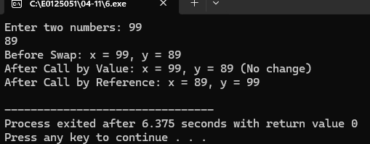

7. File Reading, Writing and Updating
#include <stdio.h>
#include <stdlib.h>
int main() {
FILE *fp;
char data[100];
fp = fopen("data.txt", "w");
if (fp ==NULL) {
printf("Error opening file!\n");
exit(1);
}
printf("Enter text to write into file: ");
fgets(data, sizeof(data), stdin);
fputs(data, fp);
fclose(fp);
printf("Data written successfully.\n");
fp = fopen("data.txt", "r");
if (fp== NULL) {
printf("Error reading file!\n");
exit(1);
}
printf("\nReading from file:\n");
while (fgets(data, sizeof(data), fp) !=NULL)
printf("%s", data);
fclose(fp);
fp = fopen("data.txt", "a");
if (fp ==NULL) {
printf("Error opening file for update!\n");
exit(1);
}
printf("\n\nEnter text to append: ");
fgets(data, sizeof(data), stdin);
fputs(data, fp);
fclose(fp);
printf("File updated successfully.\n");
return 0;
}
